Setup:-
SELECT
current_database() AS database_name,
current_user AS connected_user,
version() AS postgresql_version;

CREATE SCHEMA IF NOT EXISTS stg;

SELECT schema_name
FROM information_schema.schemata
WHERE schema_name = 'stg';
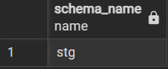

Staging:-
CREATE TABLE IF NOT EXISTS stg.dataco_cleaned_raw (
"Type" TEXT,
"Days for shipping (real)" TEXT,
"Days for shipment (scheduled)" TEXT,
"Benefit per order" TEXT,
"Sales per customer" TEXT,
"Delivery Status" TEXT,
"Late_delivery_risk" TEXT,
"Category Id" TEXT,
"Category Name" TEXT,
"Customer City" TEXT,
"Customer Country" TEXT,
"Customer Id" TEXT,
"Customer Segment" TEXT,
"Customer State" TEXT,
"Customer Zipcode" TEXT,
"Department Id" TEXT,
"Department Name" TEXT,
"Latitude" TEXT,
"Longitude" TEXT,
"Market" TEXT,
"Order City" TEXT,
"Order Country" TEXT,
"Order Customer Id" TEXT,
"order date (DateOrders)" TEXT,
"Order Id" TEXT,
"Order Item Cardprod Id" TEXT,
"Order Item Discount" TEXT,
"Order Item Discount Rate" TEXT,
"Order Item Id" TEXT,
"Order Item Product Price" TEXT,
"Order Item Profit Ratio" TEXT,
"Order Item Quantity" TEXT,
"Sales" TEXT,
"Order Item Total" TEXT,
"Order Profit Per Order" TEXT,
"Order Region" TEXT,
"Order State" TEXT,
"Order Status" TEXT,
"Product Card Id" TEXT,
"Product Category Id" TEXT,
"Product Image" TEXT,
"Product Name" TEXT,
"Product Price" TEXT,
"shipping date (DateOrders)" TEXT,
"Shipping Mode" TEXT
);


-- Check the number of imported rows
SELECT COUNT(*) AS total_rows
FROM stg.dataco_cleaned_raw;
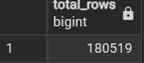

-- Check the number of columns
SELECT COUNT(*) AS total_columns
FROM information_schema.columns
WHERE table_schema = 'stg'
AND table_name = 'dataco_cleaned_raw';
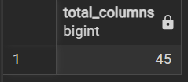

-- Inspect sample records
SELECT *
FROM stg.dataco_cleaned_raw
LIMIT 10;
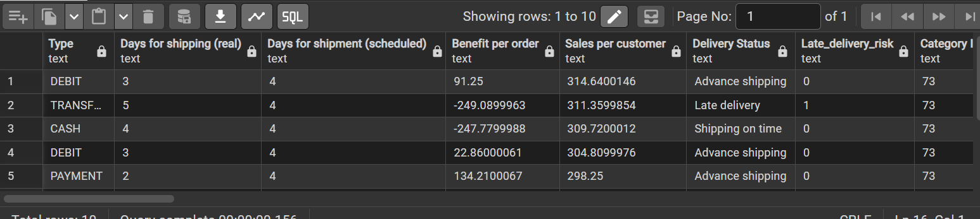

-- Validate the unique order-item identifier
SELECT
COUNT(*) AS total_rows,
COUNT("Order Item Id") AS non_null_item_ids,
COUNT(DISTINCT "Order Item Id") AS unique_item_ids
FROM stg.dataco_cleaned_raw;
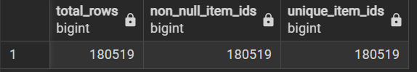

Warehouse:-
CREATE SCHEMA IF NOT EXISTS dw;
CREATE SCHEMA IF NOT EXISTS mart;

-- Verify the schemas
SELECT schema_name
FROM information_schema.schemata
WHERE schema_name IN ('stg', 'dw', 'mart')
ORDER BY schema_name;
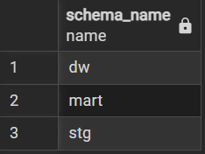

-- 1. Customer dimension
CREATE TABLE IF NOT EXISTS dw.dim_customer (
customer_key BIGINT GENERATED ALWAYS AS IDENTITY PRIMARY KEY,
customer_id BIGINT NOT NULL UNIQUE,
customer_segment TEXT,
customer_city TEXT,
customer_state TEXT,
customer_country TEXT,
customer_zipcode NUMERIC
);
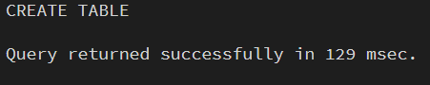

-- 2. Product dimension
CREATE TABLE IF NOT EXISTS dw.dim_product (
product_key BIGINT GENERATED ALWAYS AS IDENTITY PRIMARY KEY,
product_card_id BIGINT NOT NULL UNIQUE,
product_name TEXT,
product_price NUMERIC(18, 2),
category_id BIGINT,
category_name TEXT,
department_id BIGINT,
department_name TEXT,
product_image TEXT
);
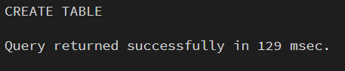

-- 3. Order geography dimension
CREATE TABLE IF NOT EXISTS dw.dim_geography (
geography_key BIGINT GENERATED ALWAYS AS IDENTITY PRIMARY KEY,
order_city TEXT,
order_state TEXT,
order_country TEXT,
order_region TEXT,
market TEXT,
UNIQUE NULLS NOT DISTINCT (
order_city,
order_state,
order_country,
order_region,
market
)
);


-- 4. Order and shipping status dimension
CREATE TABLE IF NOT EXISTS dw.dim_order_status (
order_status_key BIGINT GENERATED ALWAYS AS IDENTITY PRIMARY KEY,
shipping_mode TEXT,
delivery_status TEXT,
order_status TEXT,
UNIQUE NULLS NOT DISTINCT (
shipping_mode,
delivery_status,
order_status
)
);


-- 5. Date dimension
CREATE TABLE IF NOT EXISTS dw.dim_date (
date_key INTEGER PRIMARY KEY,
full_date DATE NOT NULL UNIQUE,
year INTEGER NOT NULL,
quarter INTEGER NOT NULL,
month INTEGER NOT NULL,
month_name TEXT NOT NULL,
day_of_month INTEGER NOT NULL,
day_of_week INTEGER NOT NULL,
day_name TEXT NOT NULL
);
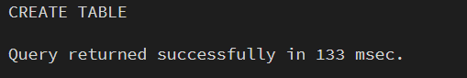

SELECT
table_schema,
table_name
FROM information_schema.tables
WHERE table_schema = 'dw'
AND table_type = 'BASE TABLE'
ORDER BY table_name;
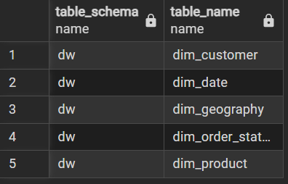

-- Load customer dimension
INSERT INTO dw.dim_customer (
customer_id,
customer_segment,
customer_city,
customer_state,
customer_country,
customer_zipcode
)
SELECT DISTINCT ON (s."Customer Id")
s."Customer Id"::BIGINT,
s."Customer Segment",
s."Customer City",
s."Customer State",
s."Customer Country",
NULLIF(TRIM(s."Customer Zipcode"), '')::NUMERIC
FROM stg.dataco_cleaned_raw s
WHERE NULLIF(TRIM(s."Customer Id"), '') IS NOT NULL
ORDER BY s."Customer Id"
ON CONFLICT (customer_id) DO NOTHING;


-- Load product dimension
INSERT INTO dw.dim_product (
product_card_id,
product_name,
product_price,
category_id,
category_name,
department_id,
department_name,
product_image
)
SELECT DISTINCT ON (s."Product Card Id")
s."Product Card Id"::BIGINT,
s."Product Name",
NULLIF(TRIM(s."Product Price"), '')::NUMERIC(18, 2),
s."Product Category Id"::BIGINT,
s."Category Name",
s."Department Id"::BIGINT,
s."Department Name",
s."Product Image"
FROM stg.dataco_cleaned_raw s
WHERE NULLIF(TRIM(s."Product Card Id"), '') IS NOT NULL
ORDER BY s."Product Card Id"
ON CONFLICT (product_card_id) DO NOTHING;
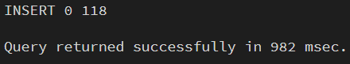

-- Load geography dimension
INSERT INTO dw.dim_geography (
order_city,
order_state,
order_country,
order_region,
market
)
SELECT DISTINCT
s."Order City",
s."Order State",
s."Order Country",
s."Order Region",
s."Market"
FROM stg.dataco_cleaned_raw s
ON CONFLICT DO NOTHING;

-- Load order and shipping status dimension
INSERT INTO dw.dim_order_status (
shipping_mode,
delivery_status,
order_status
)
SELECT DISTINCT
s."Shipping Mode",
s."Delivery Status",
s."Order Status"
FROM stg.dataco_cleaned_raw s
ON CONFLICT DO NOTHING;
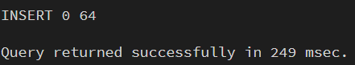

WITH all_dates AS (
SELECT DISTINCT
NULLIF(TRIM("order date (DateOrders)"), '')::TIMESTAMP::DATE AS d
FROM stg.dataco_cleaned_raw

UNION

SELECT DISTINCT
NULLIF(TRIM("shipping date (DateOrders)"), '')::TIMESTAMP::DATE AS d
FROM stg.dataco_cleaned_raw
),
valid_dates AS (
SELECT d
FROM all_dates
WHERE d IS NOT NULL
)
INSERT INTO dw.dim_date (
date_key,
full_date,
year,
quarter,
month,
month_name,
day_of_month,
day_of_week,
day_name
)
SELECT
TO_CHAR(d, 'YYYYMMDD')::INTEGER,
d,
EXTRACT(YEAR FROM d)::INTEGER,
EXTRACT(QUARTER FROM d)::INTEGER,
EXTRACT(MONTH FROM d)::INTEGER,
TO_CHAR(d, 'FMMonth'),
EXTRACT(DAY FROM d)::INTEGER,
EXTRACT(DOW FROM d)::INTEGER,
TO_CHAR(d, 'FMDay')
FROM valid_dates
ON CONFLICT (date_key) DO NOTHING;
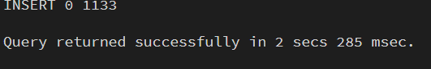

SELECT 'dim_customer' AS table_name, COUNT(*) AS row_count
FROM dw.dim_customer

UNION ALL

SELECT 'dim_product', COUNT(*)
FROM dw.dim_product

UNION ALL

SELECT 'dim_geography', COUNT(*)
FROM dw.dim_geography

UNION ALL

SELECT 'dim_order_status', COUNT(*)
FROM dw.dim_order_status

UNION ALL

SELECT 'dim_date', COUNT(*)
FROM dw.dim_date

ORDER BY table_name;
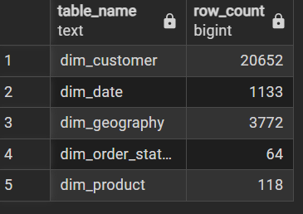

-- 1. Verify row count and order-item uniqueness
SELECT
COUNT(*) AS staging_rows,
COUNT("Order Item Id") AS non_null_item_ids,
COUNT(DISTINCT "Order Item Id") AS unique_item_ids
FROM stg.dataco_cleaned_raw;
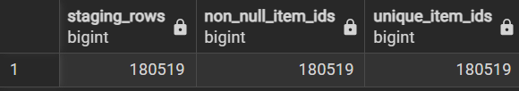

-- 2. Check whether every customer maps to the customer dimension
SELECT COUNT(*) AS unmatched_customers
FROM stg.dataco_cleaned_raw s
LEFT JOIN dw.dim_customer c
ON c.customer_id = s."Customer Id"::BIGINT
WHERE c.customer_key IS NULL;
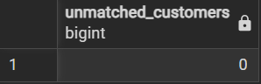

-- 3. Check whether every product maps to the product dimension
SELECT COUNT(*) AS unmatched_products
FROM stg.dataco_cleaned_raw s
LEFT JOIN dw.dim_product p
ON p.product_card_id = s."Product Card Id"::BIGINT
WHERE p.product_key IS NULL;
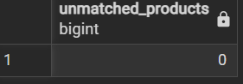

-- 4. Check order and shipping dates against the date dimension
SELECT
COUNT(*) FILTER (
WHERE od.date_key IS NULL
) AS unmatched_order_dates,
COUNT(*) FILTER (
WHERE sd.date_key IS NULL
) AS unmatched_shipping_dates
FROM stg.dataco_cleaned_raw s
LEFT JOIN dw.dim_date od
ON od.full_date =
NULLIF(TRIM(s."order date (DateOrders)"), '')::TIMESTAMP::DATE
LEFT JOIN dw.dim_date sd
ON sd.full_date =
NULLIF(TRIM(s."shipping date (DateOrders)"), '')::TIMESTAMP::DATE;
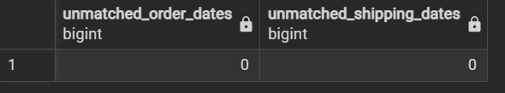

Fact Table:-

SELECT
COUNT(*) AS staging_rows,

COUNT(*) FILTER (
WHERE p.product_key IS NULL
) AS unmatched_item_products,

COUNT(*) FILTER (
WHERE g.geography_key IS NULL
) AS unmatched_geographies,

COUNT(*) FILTER (
WHERE os.order_status_key IS NULL
) AS unmatched_statuses

FROM stg.dataco_cleaned_raw s

LEFT JOIN dw.dim_product p
ON p.product_card_id = s."Order Item Cardprod Id"::BIGINT

LEFT JOIN dw.dim_geography g
ON g.order_city = s."Order City"
AND g.order_state = s."Order State"
AND g.order_country = s."Order Country"
AND g.order_region = s."Order Region"
AND g.market = s."Market"

LEFT JOIN dw.dim_order_status os
ON os.shipping_mode = s."Shipping Mode"
AND os.delivery_status = s."Delivery Status"
AND os.order_status = s."Order Status";
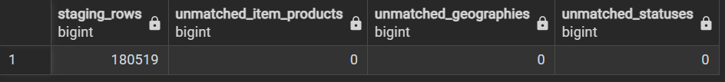

CREATE TABLE IF NOT EXISTS dw.fact_order_items (
order_item_id BIGINT PRIMARY KEY,
order_id BIGINT NOT NULL,

customer_key BIGINT NOT NULL
REFERENCES dw.dim_customer(customer_key),

product_key BIGINT NOT NULL
REFERENCES dw.dim_product(product_key),

geography_key BIGINT NOT NULL
REFERENCES dw.dim_geography(geography_key),

order_status_key BIGINT NOT NULL
REFERENCES dw.dim_order_status(order_status_key),

order_date_key INTEGER NOT NULL
REFERENCES dw.dim_date(date_key),

shipping_date_key INTEGER NOT NULL
REFERENCES dw.dim_date(date_key),

days_for_shipping_real INTEGER,
days_for_shipment_scheduled INTEGER,
late_delivery_risk INTEGER,

order_item_quantity INTEGER,
order_item_product_price NUMERIC(18, 2),
order_item_discount NUMERIC(18, 2),
order_item_discount_rate NUMERIC(12, 6),
order_item_total NUMERIC(18, 2),

sales NUMERIC(18, 2),
sales_per_customer NUMERIC(18, 2),
benefit_per_order NUMERIC(18, 2),
order_profit_per_order NUMERIC(18, 2),
order_item_profit_ratio NUMERIC(12, 6)
);
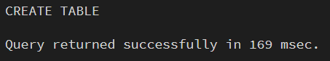

INSERT INTO dw.fact_order_items (
order_item_id,
order_id,
customer_key,
product_key,
geography_key,
order_status_key,
order_date_key,
shipping_date_key,
days_for_shipping_real,
days_for_shipment_scheduled,
late_delivery_risk,
order_item_quantity,
order_item_product_price,
order_item_discount,
order_item_discount_rate,
order_item_total,
sales,
sales_per_customer,
benefit_per_order,
order_profit_per_order,
order_item_profit_ratio
)
SELECT
s."Order Item Id"::BIGINT,
s."Order Id"::BIGINT,
c.customer_key,
p.product_key,
g.geography_key,
os.order_status_key,

TO_CHAR(
NULLIF(TRIM(s."order date (DateOrders)"), '')::TIMESTAMP::DATE,
'YYYYMMDD'
)::INTEGER,

TO_CHAR(
NULLIF(TRIM(s."shipping date (DateOrders)"), '')::TIMESTAMP::DATE,
'YYYYMMDD'
)::INTEGER,

s."Days for shipping (real)"::INTEGER,
s."Days for shipment (scheduled)"::INTEGER,
s."Late_delivery_risk"::INTEGER,

s."Order Item Quantity"::INTEGER,
s."Order Item Product Price"::NUMERIC(18, 2),
s."Order Item Discount"::NUMERIC(18, 2),
s."Order Item Discount Rate"::NUMERIC(12, 6),
s."Order Item Total"::NUMERIC(18, 2),

s."Sales"::NUMERIC(18, 2),
s."Sales per customer"::NUMERIC(18, 2),
s."Benefit per order"::NUMERIC(18, 2),
s."Order Profit Per Order"::NUMERIC(18, 2),
s."Order Item Profit Ratio"::NUMERIC(12, 6)

FROM stg.dataco_cleaned_raw s

JOIN dw.dim_customer c
ON c.customer_id = s."Customer Id"::BIGINT

JOIN dw.dim_product p
ON p.product_card_id = s."Order Item Cardprod Id"::BIGINT

JOIN dw.dim_geography g
ON g.order_city = s."Order City"
AND g.order_state = s."Order State"
AND g.order_country = s."Order Country"
AND g.order_region = s."Order Region"
AND g.market = s."Market"

JOIN dw.dim_order_status os
ON os.shipping_mode = s."Shipping Mode"
AND os.delivery_status = s."Delivery Status"
AND os.order_status = s."Order Status"

ON CONFLICT (order_item_id) DO NOTHING;
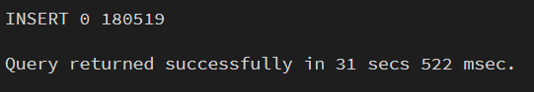

SELECT
COUNT(*) AS fact_rows,
COUNT(DISTINCT order_item_id) AS unique_order_items,
COUNT(*) FILTER (
WHERE customer_key IS NULL
OR product_key IS NULL
OR geography_key IS NULL
OR order_status_key IS NULL
OR order_date_key IS NULL
OR shipping_date_key IS NULL
) AS rows_with_missing_keys,
SUM(sales) AS total_sales,
SUM(order_item_total) AS total_order_item_value
FROM dw.fact_order_items;
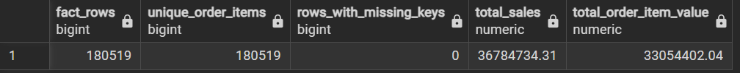

Validate financial metrics:-

SELECT
COUNT(*) AS order_item_rows,
COUNT(DISTINCT order_id) AS distinct_orders,

ROUND(SUM(sales), 2) AS total_sales,
ROUND(SUM(order_item_total), 2) AS total_order_item_value,
ROUND(SUM(order_item_discount), 2) AS total_item_discount,

ROUND(SUM(benefit_per_order), 2) AS sum_benefit_per_order,
ROUND(SUM(order_profit_per_order), 2) AS sum_order_profit_per_order,

ROUND(AVG(order_item_profit_ratio)::NUMERIC, 4)
AS average_item_profit_ratio,

COUNT(*) FILTER (
WHERE late_delivery_risk = 1
) AS items_flagged_for_late_delivery,

ROUND(
100.0 * COUNT(*) FILTER (
WHERE late_delivery_risk = 1
) / NULLIF(COUNT(*), 0),
2
) AS late_delivery_risk_pct

FROM dw.fact_order_items;

SELECT
COUNT(*) AS orders_checked,

COUNT(*) FILTER (
WHERE item_count > 1
) AS multi_item_orders,

COUNT(*) FILTER (
WHERE item_count > 1
AND distinct_profit_values = 1
) AS multi_item_orders_with_repeated_profit,

COUNT(*) FILTER (
WHERE item_count > 1
AND distinct_benefit_values = 1
) AS multi_item_orders_with_repeated_benefit

FROM (
SELECT
order_id,
COUNT(*) AS item_count,
COUNT(DISTINCT order_profit_per_order)
AS distinct_profit_values,
COUNT(DISTINCT benefit_per_order)
AS distinct_benefit_values
FROM dw.fact_order_items
GROUP BY order_id
) order_checks;

-- A. Check relationships between financial fields
SELECT
COUNT(*) AS total_items,

COUNT(*) FILTER (
WHERE ABS(
sales - order_item_total - order_item_discount
) <= 0.02
) AS rows_matching_sales_minus_total_equals_discount,

COUNT(*) FILTER (
WHERE ABS(
sales - (
order_item_product_price * order_item_quantity
)
) <= 0.02
) AS rows_matching_price_times_quantity,

COUNT(*) FILTER (
WHERE ABS(
benefit_per_order - order_profit_per_order
) <= 0.01
) AS rows_with_matching_profit_fields,

ROUND(
SUM(sales - order_item_total - order_item_discount),
2
) AS total_financial_difference

FROM dw.fact_order_items;

-- B. Inspect actual delivery statuses
SELECT
delivery_status,
late_delivery_risk,
COUNT(*) AS item_count
FROM dw.fact_order_items f
JOIN dw.dim_order_status os
ON os.order_status_key = f.order_status_key
GROUP BY delivery_status, late_delivery_risk
ORDER BY item_count DESC;
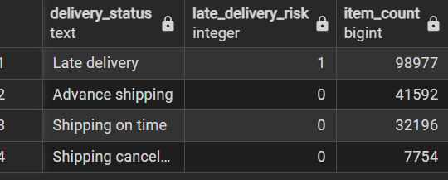

-- C. Check order-item quantity and financial values
SELECT
COUNT(*) FILTER (
WHERE order_item_quantity <= 0
) AS nonpositive_quantities,

COUNT(*) FILTER (
WHERE sales < 0
) AS negative_sales_rows,

COUNT(*) FILTER (
WHERE order_item_discount < 0
) AS negative_discount_rows,

COUNT(*) FILTER (
WHERE order_item_total < 0
) AS negative_item_total_rows,

COUNT(*) FILTER (
WHERE benefit_per_order < 0
) AS negative_benefit_rows,

COUNT(*) FILTER (
WHERE order_profit_per_order < 0
) AS negative_profit_rows

FROM dw.fact_order_items;

CREATE OR REPLACE VIEW mart.vw_executive_kpis AS
SELECT
COUNT(*) AS total_order_items,
COUNT(DISTINCT f.order_id) AS total_orders,
COUNT(DISTINCT f.customer_key) AS total_customers,

ROUND(SUM(f.sales), 2) AS total_sales,
ROUND(SUM(f.order_item_total), 2) AS total_order_item_value,
ROUND(SUM(f.order_item_discount), 2) AS total_discounts,

ROUND(SUM(f.order_profit_per_order), 2)
AS dataset_reported_profit,

ROUND(
100.0 * COUNT(*) FILTER (
WHERE os.delivery_status = 'Late delivery'
) / NULLIF(COUNT(*), 0),
2
) AS late_delivery_share_all_items_pct,

ROUND(
100.0 * COUNT(*) FILTER (
WHERE os.delivery_status = 'Late delivery'
) / NULLIF(
COUNT(*) FILTER (
WHERE os.delivery_status <> 'Shipping canceled'
),
0
),
2
) AS late_delivery_rate_excluding_canceled_pct,

ROUND(
AVG(f.days_for_shipping_real)::NUMERIC,
2
) AS avg_actual_shipping_days,

ROUND(
AVG(f.days_for_shipment_scheduled)::NUMERIC,
2
) AS avg_scheduled_shipping_days

FROM dw.fact_order_items f
JOIN dw.dim_order_status os
ON os.order_status_key = f.order_status_key;
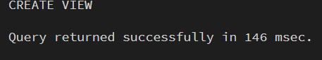

SELECT *
FROM mart.vw_executive_kpis;

CREATE OR REPLACE VIEW mart.vw_monthly_performance AS
SELECT
DATE_TRUNC('month', d.full_date)::DATE AS order_month,

COUNT(*) AS total_order_items,
COUNT(DISTINCT f.order_id) AS total_orders,

ROUND(SUM(f.sales), 2) AS total_sales,
ROUND(SUM(f.order_item_total), 2) AS total_order_item_value,
ROUND(SUM(f.order_item_discount), 2) AS total_discounts,

ROUND(SUM(f.order_profit_per_order), 2)
AS dataset_reported_profit,

ROUND(
100.0 * SUM(f.order_profit_per_order)
/ NULLIF(SUM(f.sales), 0),
2
) AS dataset_reported_profit_margin_pct,

ROUND(
100.0 * COUNT(*) FILTER (
WHERE os.delivery_status = 'Late delivery'
) / NULLIF(
COUNT(*) FILTER (
WHERE os.delivery_status <> 'Shipping canceled'
),
0
),
2
) AS late_delivery_rate_excluding_canceled_pct

FROM dw.fact_order_items f
JOIN dw.dim_date d
ON d.date_key = f.order_date_key
JOIN dw.dim_order_status os
ON os.order_status_key = f.order_status_key

GROUP BY DATE_TRUNC('month', d.full_date)::DATE;


CREATE OR REPLACE VIEW mart.vw_product_performance AS
SELECT
p.product_card_id,
p.product_name,
p.category_name,
p.department_name,

COUNT(*) AS total_order_items,
COUNT(DISTINCT f.order_id) AS distinct_orders,
SUM(f.order_item_quantity) AS units_sold,

ROUND(SUM(f.sales), 2) AS total_sales,
ROUND(SUM(f.order_item_discount), 2) AS total_discounts,
ROUND(SUM(f.order_item_total), 2) AS total_order_item_value,

ROUND(SUM(f.order_profit_per_order), 2)
AS dataset_reported_profit,

ROUND(
100.0 * SUM(f.order_profit_per_order)
/ NULLIF(SUM(f.sales), 0),
2
) AS dataset_reported_profit_margin_pct

FROM dw.fact_order_items f
JOIN dw.dim_product p
ON p.product_key = f.product_key

GROUP BY
p.product_card_id,
p.product_name,
p.category_name,
p.department_name;


-- Monthly performance, newest month first
SELECT *
FROM mart.vw_monthly_performance
ORDER BY order_month DESC;
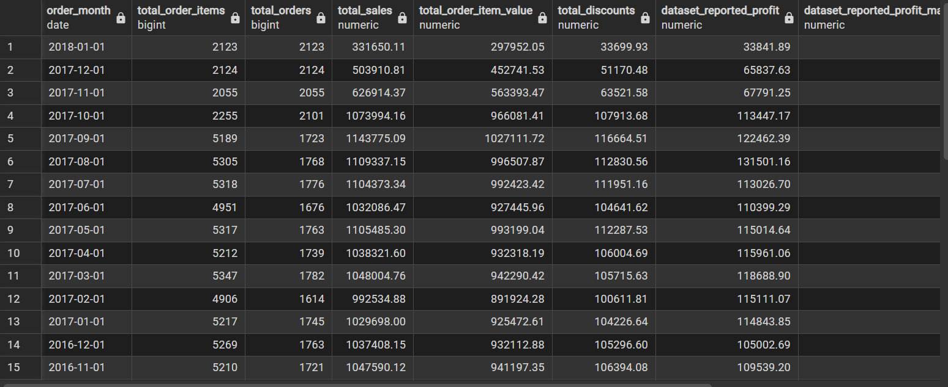

-- Top 10 products by sales
SELECT *
FROM mart.vw_product_performance
ORDER BY total_sales DESC
LIMIT 10;
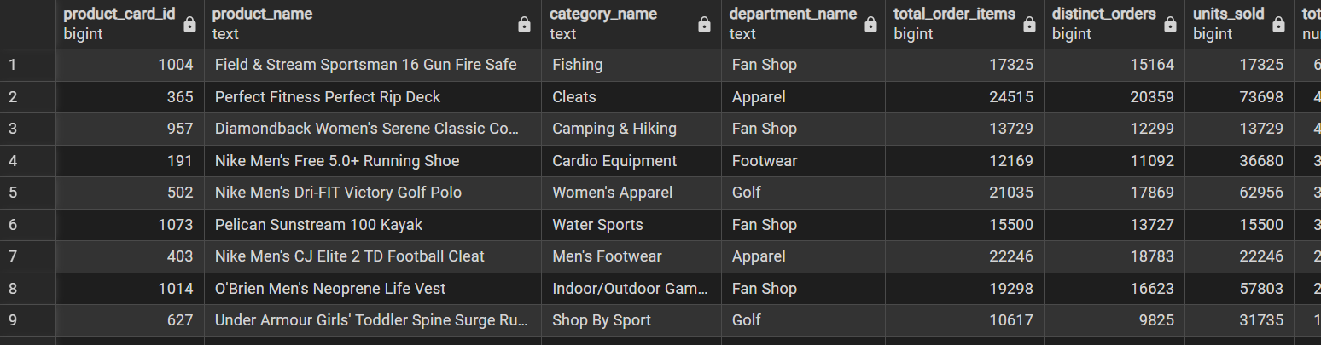

-- Category-level summary
SELECT
category_name,
SUM(total_order_items) AS total_order_items,
SUM(units_sold) AS units_sold,
ROUND(SUM(total_sales), 2) AS total_sales,
ROUND(SUM(total_discounts), 2) AS total_discounts,
ROUND(SUM(dataset_reported_profit), 2)
AS dataset_reported_profit
FROM mart.vw_product_performance
GROUP BY category_name
ORDER BY total_sales DESC;
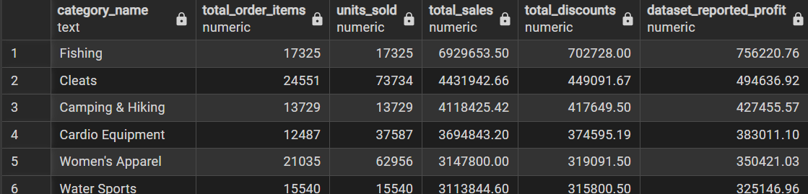

CREATE OR REPLACE VIEW mart.vw_customer_segment_performance AS
SELECT
c.customer_segment,
COUNT(DISTINCT f.customer_key) AS total_customers,
COUNT(DISTINCT f.order_id) AS total_orders,
COUNT(*) AS total_order_items,
SUM(f.order_item_quantity) AS units_sold,

ROUND(SUM(f.sales), 2) AS total_sales,
ROUND(SUM(f.order_item_discount), 2) AS total_discounts,
ROUND(SUM(f.order_profit_per_order), 2)
AS dataset_reported_profit,

ROUND(
100.0 * SUM(f.order_profit_per_order)
/ NULLIF(SUM(f.sales), 0),
2
) AS dataset_reported_profit_margin_pct

FROM dw.fact_order_items f
JOIN dw.dim_customer c
ON c.customer_key = f.customer_key

GROUP BY c.customer_segment;
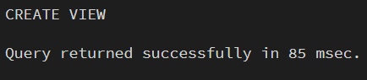

CREATE OR REPLACE VIEW mart.vw_geography_performance AS
SELECT
g.market,
g.order_region,
g.order_country,
g.order_state,
g.order_city,

COUNT(DISTINCT f.order_id) AS total_orders,
COUNT(*) AS total_order_items,

ROUND(SUM(f.sales), 2) AS total_sales,
ROUND(SUM(f.order_profit_per_order), 2)
AS dataset_reported_profit,

ROUND(
100.0 * COUNT(*) FILTER (
WHERE os.delivery_status = 'Late delivery'
) / NULLIF(
COUNT(*) FILTER (
WHERE os.delivery_status <> 'Shipping canceled'
),
0
),
2
) AS late_delivery_rate_excluding_canceled_pct

FROM dw.fact_order_items f
JOIN dw.dim_geography g
ON g.geography_key = f.geography_key
JOIN dw.dim_order_status os
ON os.order_status_key = f.order_status_key

GROUP BY
g.market,
g.order_region,
g.order_country,
g.order_state,
g.order_city;
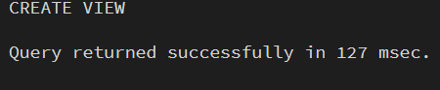

CREATE OR REPLACE VIEW mart.vw_shipping_performance AS
SELECT
os.shipping_mode,
os.delivery_status,
f.late_delivery_risk,

COUNT(*) AS total_order_items,
COUNT(DISTINCT f.order_id) AS total_orders,

ROUND(AVG(f.days_for_shipping_real)::NUMERIC, 2)
AS avg_actual_shipping_days,

ROUND(AVG(f.days_for_shipment_scheduled)::NUMERIC, 2)
AS avg_scheduled_shipping_days,

ROUND(SUM(f.sales), 2) AS total_sales,

ROUND(
100.0 * COUNT(*) / NULLIF(
SUM(COUNT(*)) OVER (
PARTITION BY os.shipping_mode
),
0
),
2
) AS pct_of_items_within_shipping_mode

FROM dw.fact_order_items f
JOIN dw.dim_order_status os
ON os.order_status_key = f.order_status_key

GROUP BY
os.shipping_mode,
os.delivery_status,
f.late_delivery_risk;
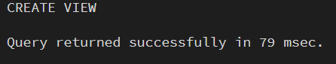

-- Customer segment performance
SELECT *
FROM mart.vw_customer_segment_performance
ORDER BY total_sales DESC;
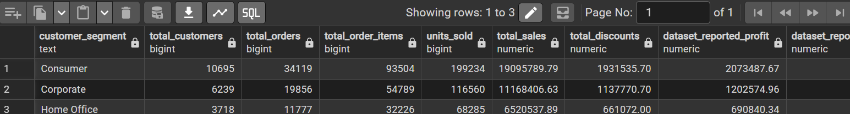

-- Top 15 countries by sales
SELECT
order_country,
SUM(total_orders) AS summed_city_order_counts,
SUM(total_sales) AS total_sales,
SUM(dataset_reported_profit) AS dataset_reported_profit
FROM mart.vw_geography_performance
GROUP BY order_country
ORDER BY total_sales DESC
LIMIT 15;
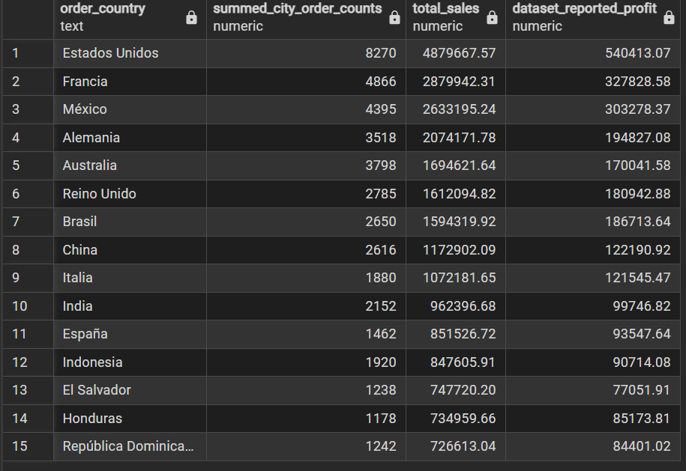

-- Shipping performance
SELECT *
FROM mart.vw_shipping_performance
ORDER BY shipping_mode, total_order_items DESC;
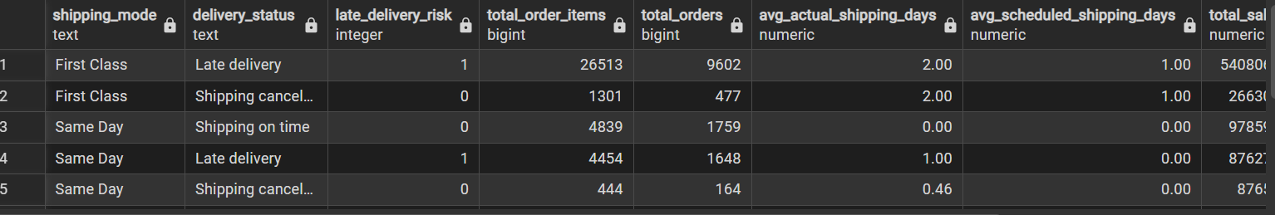

SELECT
os.shipping_mode,

COUNT(*) FILTER (
WHERE os.delivery_status = 'Late delivery'
) AS late_items,

COUNT(*) FILTER (
WHERE os.delivery_status = 'Shipping on time'
) AS on_time_items,

COUNT(*) FILTER (
WHERE os.delivery_status = 'Advance shipping'
) AS advance_items,

COUNT(*) FILTER (
WHERE os.delivery_status = 'Shipping canceled'
) AS canceled_items,

ROUND(
100.0 * COUNT(*) FILTER (
WHERE os.delivery_status = 'Late delivery'
) / NULLIF(
COUNT(*) FILTER (
WHERE os.delivery_status <> 'Shipping canceled'
),
0
),
2
) AS late_delivery_rate_pct,

ROUND(SUM(f.sales), 2) AS total_sales

FROM dw.fact_order_items f
JOIN dw.dim_order_status os
ON os.order_status_key = f.order_status_key

GROUP BY os.shipping_mode
ORDER BY late_delivery_rate_pct DESC;
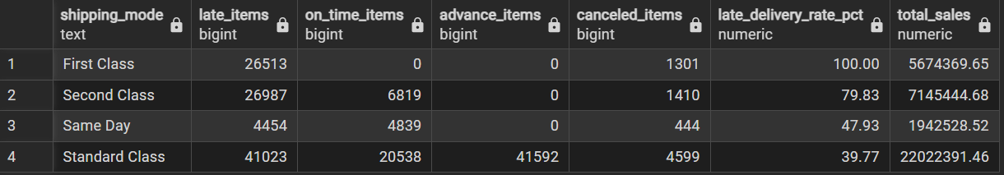

SELECT
g.order_country,
COUNT(DISTINCT f.order_id) AS distinct_orders,
COUNT(*) AS total_order_items,
COUNT(DISTINCT f.customer_key) AS distinct_customers,
ROUND(SUM(f.sales), 2) AS total_sales,
ROUND(SUM(f.order_item_discount), 2) AS total_discounts,
ROUND(SUM(f.order_profit_per_order), 2)
AS dataset_reported_profit

FROM dw.fact_order_items f
JOIN dw.dim_geography g
ON g.geography_key = f.geography_key

GROUP BY g.order_country
ORDER BY total_sales DESC
LIMIT 15;
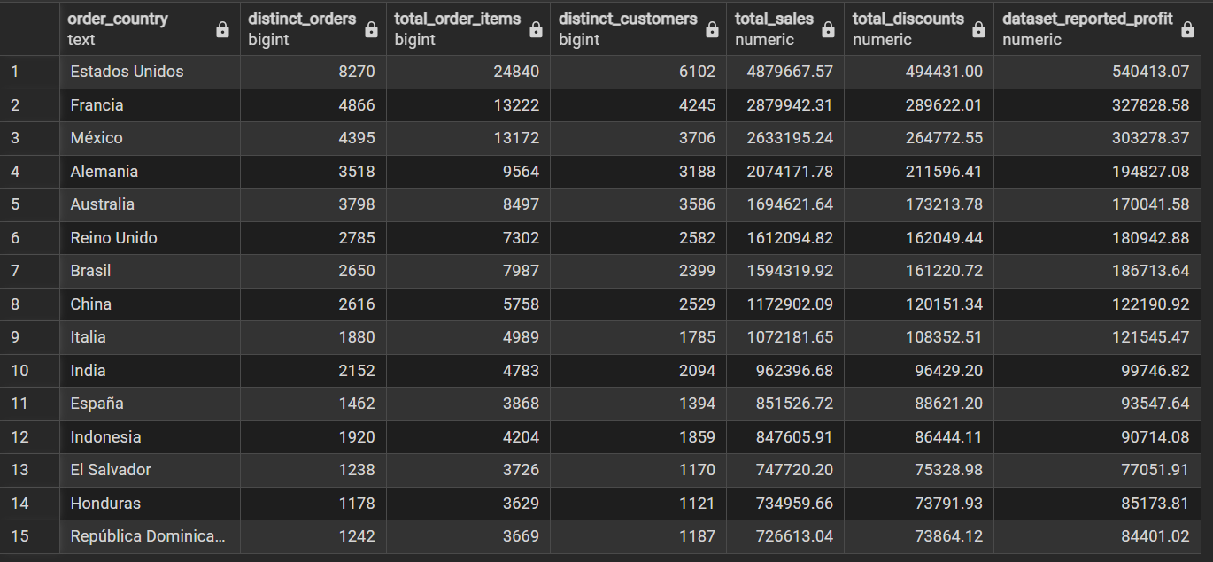

-- Compare the fact table with the executive KPI view
SELECT
(SELECT COUNT(*) FROM dw.fact_order_items)
AS fact_rows,

(SELECT SUM(sales) FROM dw.fact_order_items)
AS fact_sales,

(SELECT SUM(total_sales) FROM mart.vw_monthly_performance)
AS monthly_view_sales,

(SELECT SUM(total_sales) FROM mart.vw_product_performance)
AS product_view_sales,

(SELECT SUM(total_sales) FROM mart.vw_customer_segment_performance)
AS segment_view_sales,

(SELECT SUM(total_sales) FROM mart.vw_geography_performance)
AS geography_view_sales,

(SELECT SUM(total_sales) FROM mart.vw_shipping_performance)
AS shipping_view_sales;

